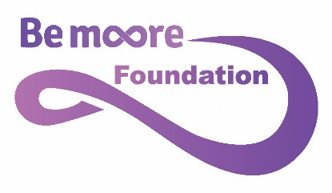

Referral Application Form
The Bemoore Foundation Community Interest Company (CIC) – Reg Co. umber 12283286
Please complete the form in as much details as possible – all information I held confidentially and will be used to complete the referral process and allow us to decide the effectiveness of the program and the best match in terms of support and coaching.
Please be aware that the Foundation program is not designed to give therapeutic long term support but works in the coaching space of lifting confidence and self-esteem. Some candidates may not benefit from the program as they require more intense or long term therapies.
We aim to first and foremost support those individuals and families who cannot access private practice.
Please also note that we look to include individuals from all backgrounds regardless of race, religion, disability, ethnicity.

- Full Name of Referral Individual: add in preferred name and preferred pro nouns:

- DOB:
- Age:
- Home Address

- Name of Organisation that is Sponsoring ( i.e., charity, school etc)

- Name of Individual Sponsor from Organisation

- Reason for Referral – please give details as to what behaviour has been observed that the programme can support.

- Benefits You Believe will be gained from taking part in the program.

- Please give details of prior support i.e. – CHAMS, CHUMS, Pastoral School Support, SEN (D) or other referred specialists such as therapists, CBT etc. Please indicate when and for how long and the perceived outcome.

- Please tick the following to indicate current or prior behaviours/concerns:
  - Self-Harm (cutting or picking at skin, pulling out hair for example)
  - Eating Anxiety or Disorders
  - Selective mutism
  - Severe school anxiety
  - School refusal,
- Please indicate any diagnosed conditions such as ADD, ADHD, body dysmorphia , anorexia, bulimia , depression , diagnosed anxiety.

- Contact details for Sponsor.

- Location of Organisation Requesting Referral

- Sponsor Signature and Declaration
I the undersigned believe with best knowledge that the information given is true. I understand that if a placement if offered I will be a point of contact for the coach and the participant to support their progress in the program.
Please type your full name below:

